Biologie Zusammenfassung 19. 09. 2020

# Organic molecules

Organic molecules are molecules, that contain energy, which can be used by animals/plants etc. These molecules are more complex and bigger than inorganic molecules.

### Inorganic molecules are:

Water

Carbon dioxide

Oxygen

Salts (Bigger but still inorganic)

### Organic molecules are:

**Carbohydrates:**

Mono- / Di- / Polysaccharides (C, H, O) Consist of monosaccharides

**Lipids:**

Triglycerides (fats/oils) (C, H, O) Consist of glycerol and fatty acids

Phospholipids (C, H, O, P, N) Consist of glycerol and fatty acids and phosphatid group

**Proteins**

Single chain protein (C, H, O, N, S) Consist of amino acids

Multiple chain protein (C, H, O, N, S) Consist of amino acids

**Nucleic acids**

Single stranded nucleic acid (RNA) (C, H, O, P, N) Consist of nucleotides*

Double stranded nucleic acid (DNA) (C, H, O, P, N) Consist of nucleotides*

Nucleotides* consist of monosaccharide (C, H, O), phophate (H, O, P) and base (C, H, O, N).

# Enzymes

Enzymes reduce the activation energy for a reaction. Most enzymes are proteins. Enzymes are most effective at about 38 degrees, because above that, the enzyme will get unstable. Enzymes are substrate and reaction specific. The substrate will get bound to the active side of the enzyme, where the reaction will take place. Different enzymes work at different PH-values.

To control the amount of enzymes that do the reaction, we need inhibitors. There are two types:

Competitive inhibitors can bind to active side of the enzyme, thus stopping substrates from getting there.

Allosteric inhibitors bind to the enzyme (not on the active side) and change the shape of the enzyme. Like that no substrates can bind to it anymore aswell.

# Energy metabolism

The process to get energy out of organic molecules is called respiration. There are two types:

**Aerobic respiration** requires oxygen to work. It breaks the organic molecules down into inorganic molecules releasing energy in form of ATP.

**Anaerobic respiration** doesn’t need oxygen, but it can only break organic molecules down into smaller organic molecules releasing less energy.

Anaerobic respiration can either create alcohol or lactic acid. Yeast creates alcohol (C2H5OH), muscle cells create lactic acid (C3H6O3). Anaerobic respiration creates 2 ATP per glucose molecule.

Aerobic respiration breaks glucose down into carbon dioxide and water. That creates 38 ATP which is 19x more efficient than anaerobic respiration.

This respiration takes place in the cytosol and in mitochondrion. A mitochondrion has two membranes. The inner membrane is folded. It has its own DNA and ribosome.

# Photosynthesis

The cells responsible for photosynthesis are chloroplasts. They have 2 membranes. Their structure is pretty similar to the one of mitochondrion. In the inner membrane there is the chlorophyll. The light dependent reaction takes place there. The light independent reaction takes place in the basic substance of the chloroplast.

Different plants need different light wavelengths. Normal green plants need everything but the green wavelengths 🡪 look green.

The whole chemical equation is: 6H2O + 6CO2 🡪 C6H12O6 + 6O2

But actually there are 2 reactions:

Light dependent reaction creates ATP of H2O (and ADT) and O2 as waste product.

The ATP then goes to the light independent reaction, which creates sugar out of CO2 and ATP.

# Overview of plant & animal metabolism

**Plants:**

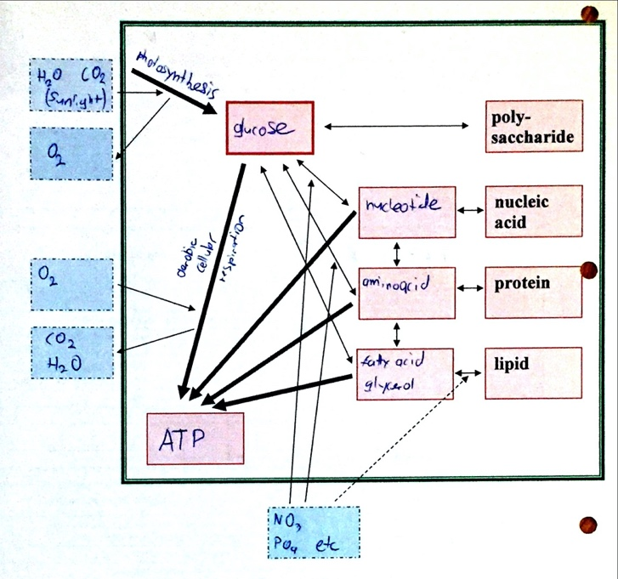

**Animals:**

